**Web Assignment # 03:**

**Task 01:**

**Outputs:**

**=> when bulb is initially in rest**

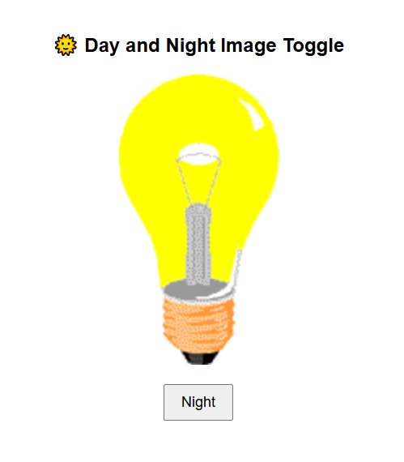

* **When bulb is turn off:’**

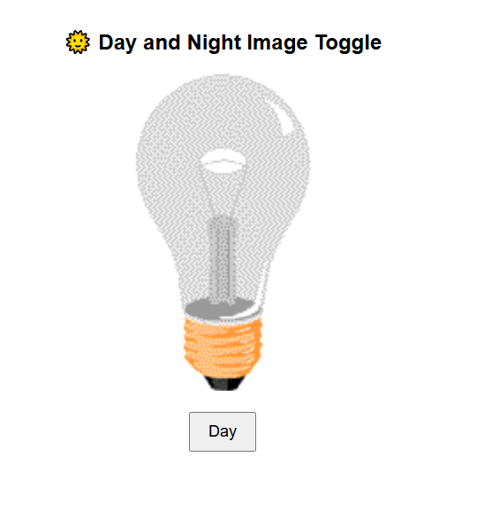

* **Bulb with shadow:**

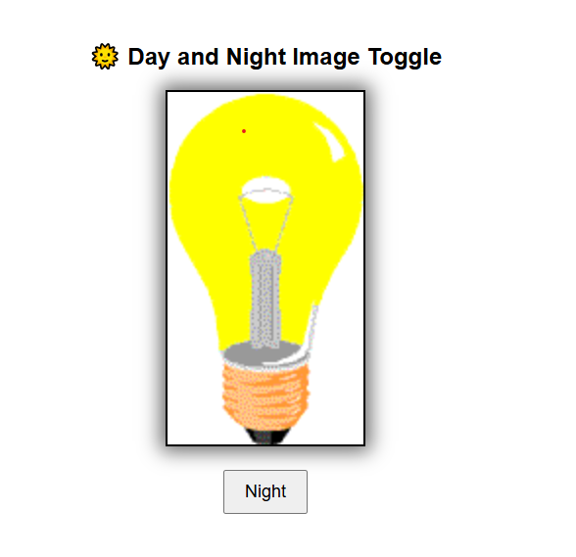

**Task 02:**

**Outputs:**

* **Output without click the items:**

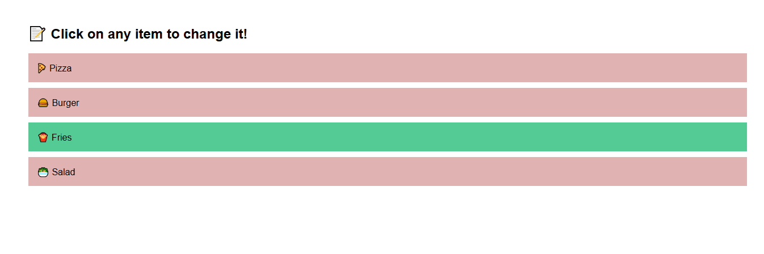

* **Output when we click the items:**

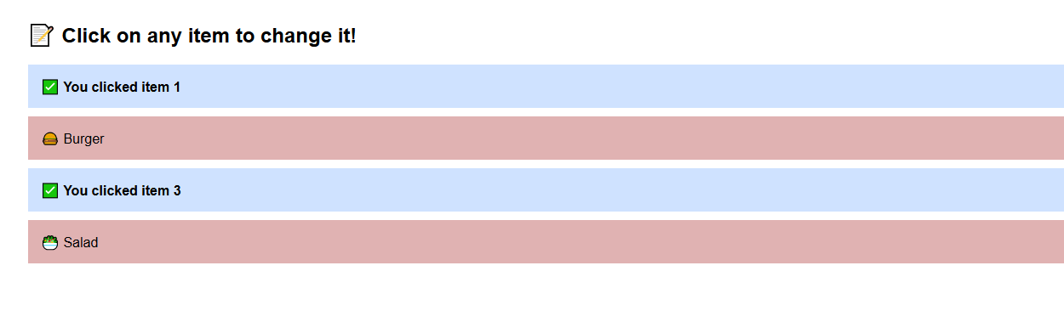

**Task 03:**

**Outputs:**

* **Simple page:**

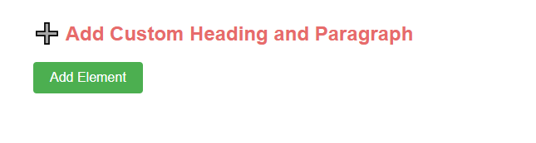

* **Take heading type:**

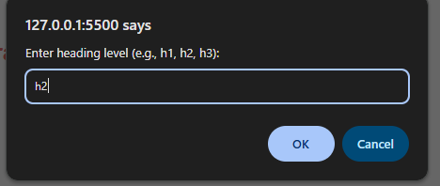

* **Write heading text:**

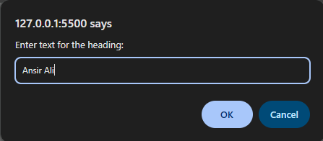

* **Write paragraph text:**

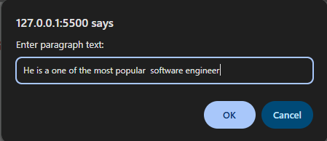

* **Final Output:**

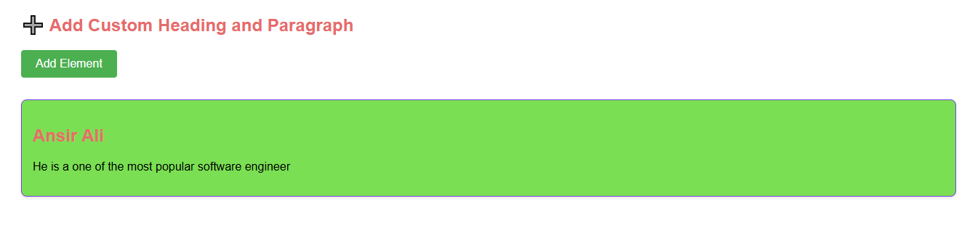

**Task 04:**

**Outputs:**

* **Simple form:**

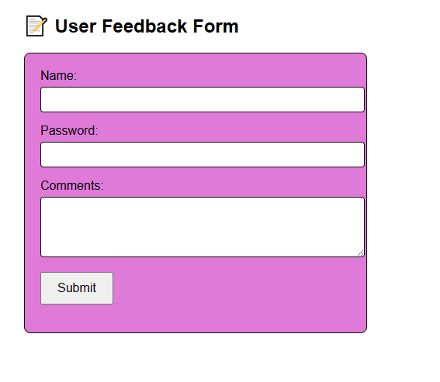

* **Form with error:**

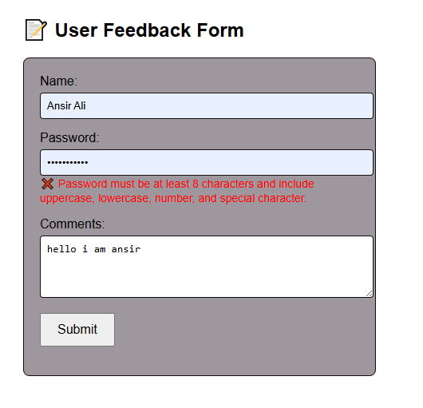

* **When form submitted successfully:**

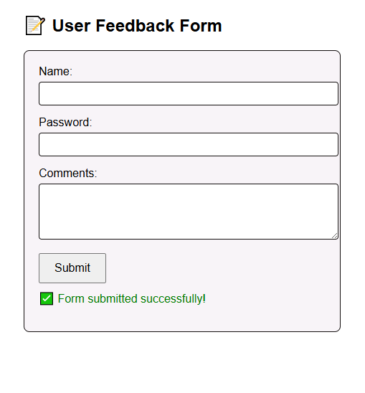

😊 **Thanks** 😄